Your Group Name
Dear Supporters:
Our group needs your help raising some extra money for the Your Group Name. Our goal is to raise at least $XX, or for each student to sell just XX items or more. We will be selling the Product from MCM Fundraising, Inc. Product are delicious premium frozen foods that buyers will truly enjoy!

Thank you for your Help!
(Coordinator’s Name Here)

Thank You

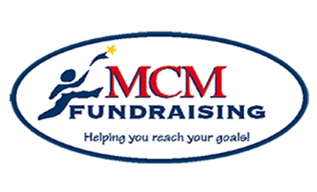

Help us reach our goal!

Group Goal: $XXX
XX or more items
Fundraiser Purpose: (FR Purpose)
Incentive Program: sellxx to receivexx

Remember:
Everyone that participates makes a difference

MCM Fundraising, Inc.
672 Dart Hill Road, Vernon, CT 06066
Office: (888) 774-5889 860-375-8138
mcmteam@mcmfundraising.com
www.mcmfundraising.com

