Your Group Name
Dear Supporters:
Our group needs your help raising some extra money for Child/StudentName. Our goal is to raise at least $XX, or for each student to sell just XX items or more. Profits from these sales will go towards your child/students individual account and go towards activity/trip.
We will be selling the Product from MCM Fundraising, Inc. Product are delicious premium foods that buyers will truly enjoy!
Thank you for your Help!
(Coordinator’s Name Here)

Thank You

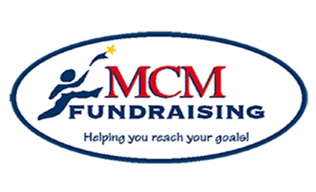

Help me reach my goal!

Individual Goal: $XXX
XX or more items
Fundraiser Purpose: (FR Purpose)
Incentive Program: sellxx to receivexx

Remember:
Everyone that participates makes a difference

MCM Fundraising, Inc.
672 Dart Hill Road, Vernon, CT 06066
Office: (888) 774-5889 860-375-8138
mcmteam@mcmfundraising.com
www.mcmfundraising.com

